Reopening During COVID-19 Guidance

Contents
Introduction 2
Resources from Federal, State and Local Sources 4
Considerations before Reopening 7
Policies, Procedures and Other Considerations as a Program Reopens 9
Appendix A: Risk/Benefit Assessment 18
Appendix B: Exploring Financial Options Under Current Conditions 19
Appendix C: Sample Letters, Policies and Procedures 21
Appendix D: Sample Day-to-Day Checklist 30

The information contained in this document was compiled and curated in collaboration with staff from the with staff from the Wisconsin Early Childhood Association, The City of Madison Child Care Unit and in collaboration with Abbi Kruse, Executive Director, The Playing Field and Paul Newton, Executive Director, Big Oak Child Care

Introduction
Current Context
COVID-19 is a respiratory illness caused by a novel virus that has been spreading worldwide. We are gaining more understanding of COVID-19’s epidemiology, clinical course, and other factors as time progresses, and the situation is changing daily. The Department of Health Services is in the process of monitoring COVID-19, providing guidance on testing with local and federal partners, and providing guidance and resources to prevent, detect and respond to the occurrence of COVID-19 cases in Wisconsin.

At this time, DHS is identifying more positive cases of COVID-19 in Wisconsin. Programs should prepare for possible impacts of COVID-19 and take precautions to prevent the spread of COVID-19, as well as other infectious diseases, including influenza.

Executive Order
Under the ‘Safer at Home’ order, child care teachers, providers, and staff are exempt and encouraged to stay open during massive state-wide closure. Additionally, The Safer at Home to Badger Bounce Back, child care is prioritized to open in phase 1 so that other sectors that rely on it can open next. Child care is a critical function in supporting the overall Wisconsin workforce. Although we do not have a clear idea when Governor Evers’ Executive Order limiting group size for child care will be lifted or revised, health information suggests that communities (workplaces, schools, business, and child care centers) will be doing so gradually, rather than all at once. For this reason, we have included considerations for reopening in phases. Our goals are to assist you in anticipating questions and considerations so that you can make as many decisions as possible in advance.

Essential Employees
While still under the Safe at Home Orders, providers should use their best judgement to verify the employment of essential workforce families.

DCF Essential Workforce Definition:
- Tier 1: employees, contractors, and other support staff working in health care;
- Tier 2: employees, contractors, and other staff in vital areas including but not limited to military; long term care; residential care; pharmacies; child care; child welfare; government operations; public safety and critical infrastructure such as sanitation, transportation, utilities, telecommunications; grocery and food services; supply chain operations; and other sectors as determined by the Secretary of the Department of Children and Families.

Communication
We ask that you visit the Department of Children and Families COVID-19 Child Care Resources page to keep abreast of changing state guidance on program reopening. It is important that all programs currently operating provide the same level of care and health precautions for staff and children. As you move forward with this work, you must establish communication with your DCF licensor to notify them of any and all plans you have to provide emergency care and make updates about your program in the Provider Portal and maintain communication with your YoungStar consultant.

Risk Sharing Guidance
Consider sharing risk guidance from the Centers for Disease Control and Prevention (CDC) with staff and families, and ask that all – including those who have members in their household with compromised immune systems, respiratory problems, hypertension, diabetes, heart problems, chronic kidney disease, or cancer - sign a document stating they are aware of the risks associated with COVID-19.

Revisions
We will attempt to revise this document as new information is available. It is possible that new Executive Orders or public health guidance will be issued after this document is made public.

Resources from Federal, State and Local Sources
Economic Recovery Rebates
Authorizes recovery rebates of $1,200 for all Americans with adjusted gross income up to $75,000 ($112,500 for head of household) and $2,400 for married couples with adjusted gross income up to $150,000 who file a joint return. Amounts increase by $500 for every child.
Payroll Protection Program
This is a payroll-focused program that offers low-interest loans to for profit, nonprofit, self-employed, and contract workers to pay staff and cover operating costs. These loans may be eligible for debt forgiveness.
Child Care and Development Block Grant
Federal Funds Information for States (FFIS) estimates that Wisconsin will receive approximately $51.3 million of the additional funding provided under the Act. While we do not know at this time how Wisconsin will spend these funds, the link above provides the federal parameters.
Child and Adult Care Food Program (CACFP)
New waivers increase CACFP flexibility, allowing child care programs to receive reimbursements for meals that do not meet the meal pattern requirements and providers can continue receiving CACFP reimbursement for distributing meals to parents or guardians to take home to their children (regardless of whether provider is open or closed for the care of children).
Economic Injury Disaster Loan (EIDL)
This is broader than PPP in the expenses it will cover (such as the full mortgage payment, not just the interest). If you meet the qualification criteria to apply for an EIDL loan, you can receive a $10,000 advance within three business days—that does not need to be repaid.
Unemployment Insurance
- Relief package will allow individuals to receive larger unemployment checks for a longer period of time.
- Employees whose hours have been reduced are eligible for a pro-rated benefits payment (and the additional $600).
- Access to unemployment benefits is expanded for individuals who are not traditionally eligible (e.g., self-employed individuals such as family child care providers; faith-based providers, part-time workers).
The Employee Retention Credit
The Employee Retention Credit is a fully refundable tax credit for employers equal to 50 percent of qualified wages (including allocable qualified health plan expenses) that Eligible Employers pay their employees.
Additional Information and Financial Counseling
If you need additional help navigating which relief packages might be best for you, there are a number of national and local organizations available to help you for free. Click the link above to find the help that meets your needs best.
Child Care Supply Needs
If you need immediate supplies and resources, please first check your local community retailers.
Supplies are flowing back into Wisconsin regularly.

The Federal Emergency Management Administration (FEMA) has set up a website to facilitate private businesses offering Personal Protective Equipment (PPE): https://fema.connectsolutions.com/ppeexchange

If you still cannot locate what you need, contact 211 Wisconsin. 211 Wisconsin can help connect you with resources in your local community. If you still cannot find what you need, please contact DCF at dcfmbcovid19@wisconsin.gov and provide your contact information and a general idea of your needs. Additionally, DCF is working with the Federal Emergency Management Agency to secure supplies in the event of wide scale shortages.

UW Extension Free Financial Counseling and Resources
The UW-Madison Extension has financial educators who can help you find resources and come up with a personal plan.
Families First Coronavirus Response Act
The Families First Coronavirus Response Act (FFCRA or Act) requires certain employers (over 50 employees) to provide their employees with expanded family and medical leave for specified reasons related to COVID-19. Small businesses with fewer than 50 employees may qualify for exemption from the requirement to provide leave due to school closings or child care unavailability if the leave requirements would jeopardize the viability of the business as a going concern.
- Two weeks (up to 80 hours) of expanded family and medical leave at the employee’s regular rate of pay where the employee is unable to work because the employee is quarantined (pursuant to Federal, State, or local government order or advice of a healthcare provider), and/or experiencing COVID-19 symptoms and seeking a medical diagnosis; or
- Two weeks (up to 80 hours) of expanded family and medical leave at two-thirds the employee’s regular rate of pay because the employee is unable to work because of a bona fide need to care for an individual subject to quarantine (pursuant to Federal, State, or local government order or advice of a healthcare provider), or care for a child (under 18 years of age) whose school or child care provider is closed or unavailable for reasons related to COVID-19, and/or the employee is experiencing a substantially similar condition as specified by the Secretary of Health and Human Services, in consultation with the Secretaries of the Treasury and Labor.
- A covered employer must provide to employees that it has employed for at least 30 days: Up to an additional 10 weeks of expanded family and medical leave at two-thirds the employee’s regular rate of pay where an employee is unable to work due to a bona fide need for leave to care for a child whose school or child care provider is closed or unavailable for reasons related to COVID-19.
- Tax Credits: Covered employers qualify for dollar-for-dollar reimbursement through tax credits for all qualifying wages paid under the FFCRA. Qualifying wages are those paid to an employee who takes leave under the Act for a qualifying reason, up to the appropriate per diem and aggregate payment caps. Applicable tax credits also extend to amounts paid or incurred to maintain health insurance coverage. For more information, please see the Department of the Treasury’s website.

Considerations before Reopening
Financial Considerations
When considering reopening, take a look at all available programs that are regularly available to child care programs and the families they serve. Some families may be newly eligible for programs there were not eligible for in the past.
Wisconsin Shares: The Wisconsin Shares Child Care Subsidy Program supports low-income working families by subsidizing a portion of the cost of quality child care so that parents or other approved caregivers may work, go to school, or participate in approved work training programs. To be initially eligible, the family's gross monthly income must be equal to or less than 185% Federal Poverty Level.
Child and Adult Care Food Program (CACFP): The CACFP provides nutritious meals and snacks to infants and children as a regular part of their child care. A variety of public or private nonprofit child care centers, Head Start programs, outside-school-hours care centers, and other institutions which are licensed or approved to provide child care services participate in CACFP. For-profit centers that serve lower income children may also be eligible. CACFP reimburses centers at free, reduced-price, or paid rates for eligible meals and snacks served to enrolled children, targeting benefits to those children most in need.
In addition to these programs, the appendices to this document provide a quick guide to help make decisions about when to reopen:
- Appendix A: This tool is a risk/benefit assessment for programs considering reopening.
- Appendix B: This is a two-step tool to exploring a program’s financial options under the current conditions. The second step involves an editable cash-flow analysis tool that can be downloaded and used by programs.
NOTE: Both of these appendices were taken with permission directly from the Virginia Early Childhood Foundation’s Guide for Virginia Child Care Providers to Navigate the COVID-19 Crisis.

Licensing and Accreditation Standards Review
All rules governing group and family child care homes shall be upheld. A complete list of changes due to COVID-19 can be found here. Additional guidance on keeping children, families and staff safe can be found here. Ratios for children under the age of 5 must be followed but center capacity can be exceeded up to 10 adults and 50 children. These rulings continue to change, it is essential that you check the DCF website in order to understand the most current rules for operations.

When reopening, plan for an in-depth staff review of already-required licensing rules and accreditation standards: hand washing, washing and sanitizing, exclusion, universal precautions. Consider which additional precautions will be employed to prevent spread of COVID outlined in the next section. Some rules and accreditation standards will have to be altered during this time period (i.e. discouraging family style meal service, cot distance while napping, etc.). We’ve developed two documents to help with these additional policies and procedures. See Appendices C and D for a sample policy/procedure document and a checklist.

Policies, Procedures and Other Considerations as a Program Reopens
Prior to the First Day a Child Attends
Capacity
In general, programs must pay close attention to the maximum enrollment levels allowed by current Public Health guidelines. Seek guidance from your licensing specialist if you have any questions about the number of children for your specific space.
- Can you do a soft opening with a few children re-enrolled and then gradually add more children week to week?
- Can you provide separate welcome back opportunities for parents/children as well as staff to reacquaint them with the program if they’ve been out of care for a significant length of time?
- If you are opening at less than full (pre-COVID) enrollment, how will you make re-enrollment decisions?
  - Consider age groups, available teaching staff and which classrooms can be open safely while maintaining physical distancing.
  - Consider any state directives to serving “Essential Workers.”
- How will you notify families of these decisions?
- What will happen with families whom you are not able to serve right away?
- If less than full (pre-COVID) enrollment, how will you decide when to increase enrollment levels?
Enrollment Related Questions
- How are you sharing information about updated and/or temporary policies and procedures with families prior to re-enrollment? See Appendix C for sample letters and policies for families.
- What additional precautionary measures might you employ around the enrollment process? For example, online enrollment and bill pay.
- While you are closed, how are you maintaining a “re-enrollment” list?
  - Will families be able to change their enrollment/contracts (i.e. moving from full time to part time)?
  - Can parents elect to hold the child’s spot beyond the reopening date? Time limit? Process?
  - Do you charge a one-time fee, weekly or monthly fee for “spot holding”?
    - How is the fee derived (% of tuition, amount needed to pay center building costs, other)?
- How are you accounting for changes in household income or other hardships?
  - What resources do you need to be able to provide them with (Wisconsin Shares, City of Madison Tuition Assistance, University of Wisconsin Madison Child Care Tuition Assistance Program, other scholarship options). If these are new revenue streams for your program, what other internal information and training is needed?
- Are your policies and procedures for disenrollment different than under normal circumstances? (E.g. length of notice, how notice is given, refunds)
- Will you need to regroup children based on different enrollment or staffing patterns?
Staffing Questions
- What are the child care needs of your current staffing pool?
  - Are your teachers able to return to work at their normal capacity?
  - Do they have unmet child care needs of their own?
  - Do they have any high-risk family members in their home?
  - Do they require a change in scheduling?
  - Can you prioritize the children of staff in care so that staff can return to work?
- Have benefits, paid time off or rate of pay changed either on a temporary or permanent basis?
  - Note: discussions with board or owners regarding benefits, paid time off etc. should happen prior to call back of staff.
- If temporary staff were hired how will they be phased out or hired permanently if needed?
  - Consider background checks and qualifications of temporary staff if they become permanent.
- Will changes in capacity, position, job description, title, classroom placement occur?
- How are staff being supported? Do you have resources for staff around reflection and self care?
- Can staff be given a day without children present to prepare their classrooms and to learn and implement new or additional procedures.
  - Will the center serve snacks and lunch from the date of reopening?
  - Will families provide lunch and snacks?
    - How will you ensure sanitation of containers going back and forth from home?
- How will you communicate your plans for reopening and policy changes to your Licensor or Certification Specialist?
- How will suspended licensing rules affect day to day operations and programming?
  - How will staff (and/or parents) be informed of this?
  - When suspended rules are no longer suspended, how will regular licensing requirements be implemented and how will staff be informed?
Other Legal Considerations
- Should any staff member who doesn’t have insurance be in a program during the reopening period of time when COVID transmission is still possible?
- Should you consult with a lawyer if you are putting employees at risk if requiring them to work and they get sick?
Note: Programs should consider consulting with legal and financial advisors to determine the best course of action for their programs.
Staff Training
Each person caring for children must receive at least an abbreviated staff orientation (emergency plans, where student information is, medications, emergency and evacuation procedures, etc.). In addition to this, the following trainings are recommended for temporary staff minimally:
- CPR, Shaken Baby and SIDS training, Child Abuse and Neglect training, administration of medication. Resources here.
- Employers must ensure workers are trained on the hazards of the cleaning chemicals used in the workplace in accordance with OSHA’s Hazard Communication standard (29 CFR 1910.1200).
- Employers must comply with OSHA’s standards on Bloodborne Pathogens (29 CFR 1910.1030), including proper disposal of regulated waste, and PPE (29 CFR 1910.132).
- Briefing on children’s special health/diet needs
- Communicable disease training including recognizing and responding to signs and symptoms of COVID-19

Ongoing Considerations and Guidance
The information provided below gives programs ideas for the types of policies and procedures that need to be developed or updated as the program reopens. Sample communication to parents about these updated policies and procedures are available in Appendix C. Appendix D contains a checklist that can be used for day-to-day operations.
medically vulnerable populations
Assess the impact of the disease on employees and students that may be at higher risk for COVID-19 health complications. In programs without healthcare staff on-site, it is recommended to have a confidential list of students with chronic illness and special health care needs. These students may be at a higher risk and need more immediate separation from other students. Maintain confidentiality of the student or staff member as required by the Americans with Disabilities Act and the Family Education Rights and Privacy Act. Consider alternatives for providing essential medical and social services for students. Continue providing necessary services for children with special healthcare needs, or work with Wisconsin Title V Children and Youth with Special Health Care Needs (CYSHCN) Program.
Cleaning and Disinfecting
- Minimize the potential for the spread of germs in the program space by temporarily removing toys that are not easily cleanable (such as stuffed animals and pillows) and rotate the toys that are out at any one time so that they can be adequately cleaned and sanitized.
- If surfaces are dirty, they should be cleaned using a detergent or soap and water prior to disinfection.
- For disinfection, diluted household bleach solutions, alcohol solutions with at least 70% alcohol, and most common EPA-registered household disinfectants should be effective. See List N: Disinfectants for Use Against SARS-CoV-2.
  - Diluted household bleach solutions can be used if appropriate for the surface. Follow manufacturer’s instructions for application and proper ventilation. Check to ensure the product is not past its expiration date. Never mix household bleach with ammonia or any other cleanser. Unexpired household bleach will be effective against coronaviruses when properly diluted.
- Prepare a bleach solution by mixing:
  - 5 tablespoons (1/3rd cup) bleach per gallon of water or
  - 4 teaspoons bleach per quart of water
  - Products with EPA-approved emerging viral pathogens claims are expected
to be effective against COVID-19 based on data for harder to kill viruses. Follow the manufacturer’s instructions for all cleaning and disinfection products (e.g., concentration, application method and contact time, etc.).
  - For soft (porous) surfaces such as carpeted floor, rugs, and drapes, remove visible contamination if present and clean with appropriate cleaners indicated for use on these surfaces. After cleaning:
  - If the items can be laundered, launder items in accordance with the manufacturer’s instructions using the warmest appropriate water setting for the items and then dry items completely.
  - Otherwise, use products with the EPA-approved emerging viral pathogens claims (examples at this link) that are suitable for porous surfaces.
- Use disinfectants in a well-ventilated space. Extensive use of disinfectant products should be done when children are not present, and the facility thoroughly aired out before children return.
- Child care facilities are encouraged to avoid the use of quaternary ammonia sanitizers and disinfectants. “Quats” are asthmagens - asthma triggers, skin irritants, endocrine disrupters and low-level disinfectants. Sodium dichloroiso-cyanurate (dichlor) tablets for sprayers that produce hypochlorous acid are safer than some sprays but are still a chlorine product and potential asthma trigger. This form of chlorine is safer than bleach. The liquid has a pH ~ 6-7 so the Department of Labor and Industry (L&I) will not require an emergency eye wash. “Fogging” – spraying chemicals in the air – is not recommended, advised, necessary, or safe.
- Child care facilities must have a Safety Data Sheet (SDS) for each chemical used in the facility.

Linens, clothing, and other items that go in the laundry
- Do not shake dirty laundry; this minimizes the possibility of dispersing virus through the air.
- Wash items as appropriate in accordance with the manufacturer’s instructions. If possible, launder items using the warmest appropriate water setting for the items and dry items completely. Dirty laundry that has been in contact with an ill person can be washed with other people’s items.
- Clean and disinfect hampers or other carts for transporting laundry according to guidance above for hard or soft surfaces.

Proper use of Personal Protective Equipment (PPE)
- Cleaning staff should wear disposable gloves and gowns for all tasks in the cleaning process, including handling trash if possible.
- Gloves and gowns should be compatible with the disinfectant products being used.
- Additional PPE might be required based on the cleaning/disinfectant products being used and whether there is a risk of splash.
- Gloves and gowns should be removed carefully to avoid contamination of the wearer and the surrounding area. Be sure to clean hands after removing gloves.
- Gloves should be removed after cleaning a room or area occupied by ill persons. Clean hands immediately after gloves are removed.
- Cleaning staff should immediately report breaches in PPE (e.g., tear in gloves) or any potential exposures to their supervisor.
- Cleaning staff and other adults in the program should clean hands often, including immediately after removing gloves and after contact with an ill person, by washing hands with soap and water for 20 seconds. If soap and water are not available and hands are not visibly dirty, an alcohol-based hand sanitizer that contains 60%-95% alcohol may be used. However, if hands are visibly dirty, always wash hands with soap and water.
  - Follow normal preventive actions while at work and home, including cleaning hands and avoiding touching eyes, nose, or mouth with unwashed hands.
  - Additional key times to clean hands include:
    - After blowing one’s nose, coughing, or sneezing
    - After using the restroom
    - Before eating or preparing food
    - After contact with animals or pets
    - Before and after providing routine care for another person who needs assistance (e.g., a child).

Safety Precautions While in Care with Children
Teach children and staff to:
- Cough or sneeze into a tissue. Throw away the tissue after they use it and wash hands.
- Avoid touching their eyes, nose, or mouth.
- Wash their hands frequently and for at least 20 seconds with soap and water, especially after going to the bathroom, before eating, and after blowing your nose, coughing, or sneezing. If soap and water are not readily available, use an alcohol-based hand sanitizer with at least 60 percent alcohol. Always wash hands with soap and water if your hands are visibly dirty.
- Avoid sharing cups and eating utensils with others.
- Field trips are discouraged at this time.

Staff Should:
- Assess the health of each person entering the building. This should be done by healthcare professional or another staff member trained by a healthcare professional.
  - Take the temperature and check symptoms for staff and children upon entry each day and ask if medications were used to lower the child’s temperature and if there are any household members with COVID-19. If forehead or disposable thermometers are not available, you can ask the caregiver to fill out and sign a form that reports their child’s temperature as taken at home (or affirming the child does not have a fever) and any symptoms (see checklist in Appendix D).
- Clean and disinfect frequently touched objects and surfaces like doorknobs, tables, drinking fountains and handrails. Regular cleaning products can be used. See an additional list of recommended products.
- If napping mats are used, children should be kept at least 6 feet apart if possible and mats should be cleaned after each use.
- Emphasize the need to remain vigilant against stigma due to perceived race, national origin, or recent travel. Foster a supportive environment free from rumors or associations of a virus with a specific population.
- On March 31, 2020, CDC recommended the following: It is important to comfort crying, sad, and/or anxious infants and toddlers, and they often need to be held. When washing, feeding, or holding very young children:
• Child care providers can protect themselves by wearing an over-large button-down, long sleeved shirt and by wearing long hair up off the collar in a ponytail or other updo.
• Child care providers should wash their hands, neck, and anywhere touched by a child’s secretions. Child care providers should change the child’s clothes if secretions are on the child’s clothes. They should change the button-down shirt, if there are secretions on it, and wash their hands again.
• Contaminated clothes should be placed in a plastic bag or washed in a washing machine. Infants, toddlers, and their providers should have multiple changes of clothes on hand in the child care center or home-based child care

Social Distancing
Incorporate social distancing within groups to the degree possible, aiming for at least three to six feet between children and minimizing the amount of time children are in close contact with each other.
- Don’t use common spaces and limit movement between classrooms. Children should only interact with the other children in their own group/pod.
- Dedicated staff should work with each group. Ideally, staff would not move between the groups of children.
- Additionally, programs should limit the movement of children across spaces. If parents/caregivers are able to (and programs can operationalize), they should drop off children without entering the building and/or classroom. Eliminate large group activities.
- Limit the number of children in each program space.
- Increase the distance between children during table work.
- Plan activities that do not require close physical contact between multiple children.
- Limit item sharing, and if items are being shared, remind children not to touch their faces and wash their hands after using these items.
- Limit use of water or sensory tables and wash hands immediately after any use of these tools.
- Minimize time standing in lines.
- Limit corridor use/traffic.
- Incorporate additional outside time and open windows frequently.
- Adjust the HVAC system to allow for more fresh air to enter the program space.
- Avoid gathering in larger groups for any reason. Outside time and lunch should be taken with group (no large gatherings or combining groups.)

Outside play
Offer outdoor play in staggered shifts. If multiple groups are outside at the same time, they should have a minimum of six feet of open space between outdoor play areas or visit these areas in shifts so that they are not congregating. Always wash hands immediately after outdoor play time. Clean off all equipment after each group uses the playground.

Drop-off and pick-up
- Do not combine groups in the morning or afternoon.
- You may wish to alternate drop off and pick up times for each small group to avoid a large number of people congregating outside the facility or in front of the facility.
- Wash hands or use hand sanitizer before and after signing in and out. No pen should be shared. Parents should use their own pen when signing in. If check-in is electronic, provide alcohol wipes and frequently clean the screens or keyboards.
- If anyone in the home has cold symptoms, caregivers should not send their children to the childcare program. Daily at drop off, the caregiver will sign off that no one in the family has cold symptoms. Children should not return until their household member is three days symptom free.
- Stagger pick up and drop off times.
- Where possible, have the staff member conduct the sign in and sign out - so that parents are not needlessly touching papers, pens, clipboards, etc. Where tablets are used, again the staff should sign the child in and out on behalf of the parents. If tablets or keyboards are used by multiple staff, they should be disinfected between each use.

Meals and Snacks
- Child and Adult Care Food Program (CACFP) guidelines should be followed for preparing and serving meals and snacks.
- Food preparation safety procedures should be followed.
- Family style serving should be avoided, if possible. It is recommended that the adults prepare each child’s plate using gloves.

Emergency Plans
- Plans are in place to notify families in case of injury or disaster.
- Plans are in place to care for children in case of a child’s or an adult’s injury.
- Plans are in place in case of fire or other disaster, including flood, tornado, intrusion, or terrorism.
- There is at least one alternate exit in case of fire.

Responding to a Confirmed COVID-19 Case in children or Staff
- If there is a case of COVID-19 among children or staff, programs should consult with Public Health to determine the need for closure of the facility. This time can be used for through cleaning and disinfection.
- If a parent has been exposed but has not been diagnosed and has no symptoms, other people in their household can participate in their usual activities. If the parent develops any symptoms or tests positive then the child should not attend care (unless the child has been separated from the exposed parent). The exposed parent should not drop off or pick up the child as long as they are in quarantine.
- Assess the impacts of any decisions you make on the families you serve. There are equity implications for any decision you may make, and the families you work with will be able to provide you the best feedback on and guidance on how to move forward in a child- and family-centered way.
- If extended facility closures are recommended by public health, programs should implement continuity of operations plans.
  - Ensure continuity of meal programs and distribution of medications.
  - Continue providing necessary services for children with special healthcare needs.
- Parents of children at increased risk of severe illness should consider implementing plans to remove children from the program.
- Maintain regular communications with parents and your local public health department.
- The staff or child diagnosed with COVID-19 should follow the DHS recommendations for isolation and quarantine, which can be found here: https://www.dhs.wisconsin.gov/dph/memos/communicable-diseases/2020-08.pdf.

Speaking to Children about COVID-19
Here are resources we will use to speak with children about the virus:
- Talking to Children About COVID-19 (Coronavirus) - A Parent Resource.
- Talking With Children: Tips for Caregivers, Parents, and Teachers During Infectious Disease Outbreaks
- CDC Guidance for talking with children

APPENDIX A

Risk/Benefit Assessment
Assessing the Benefits and Risks of Staying Open (or Reopening)To weigh the relative risks and benefits of staying open, first examine the benefits for each group—families and children, your staff and program, and your community. For each group, check the box in either the first or second column that best describes your situation. Then do the same for the risks. How many checkmarks do you have in the “Strong Benefit” (green) box versus the “Strong Risk” (red) box? Is this consistent with your values? Are there certain benefits or risks that you would weight differently? Remember that there is no perfect choice and that you are doing the best you can in an extremely difficult situation. Again, we strongly recommend that you seek advice from legal and financial advisors as you make decisions and take action.

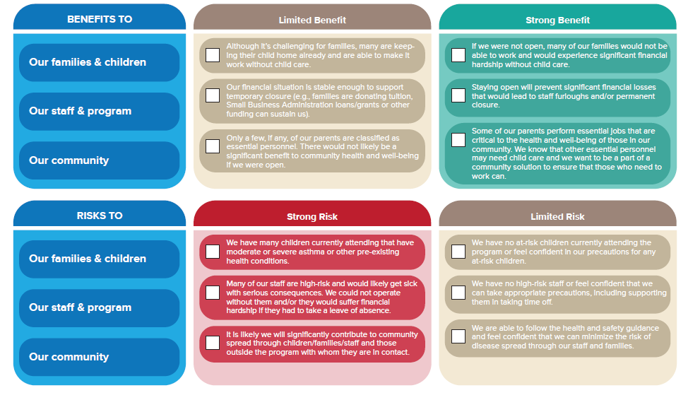

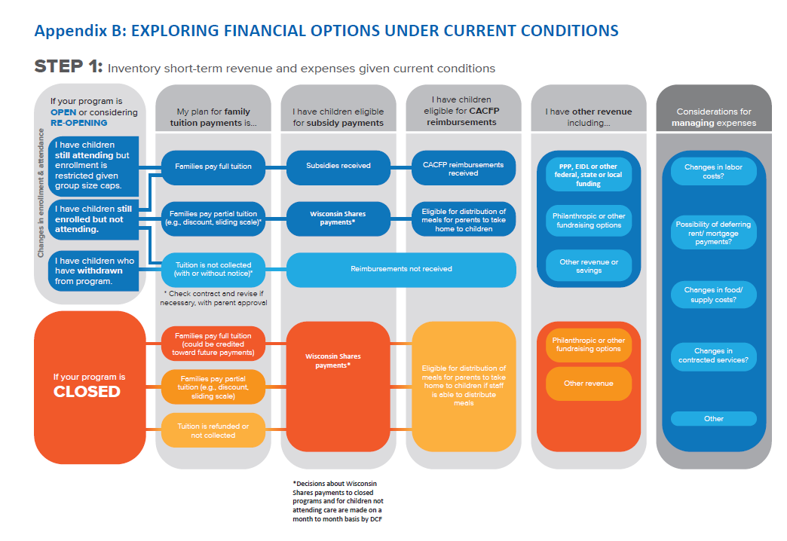dix A: Risk/Benefit Assessment
STEP 2: Calculate short-term cashflow to determine your needs using the Early Education Business Short Term Cash Flow Analysis Tool.

Appendix C: Sample Letters, Policies and Procedures

SAMPLE LETTER TO NEW FAMILIES

Dear Family:

Welcome to our program! We understand times are stressful, but we want your experience to be an exceptional one and would love to hear about ways that we can support you in your important role as parents. As we strive to create a partnership with your family in this time of need, we encourage you to provide us with any feedback you might have about your experience.

As you prepare to transition your little one into the center, there are a few things that will help to make your transition as smooth as possible.

First, please fill out all the enrollment paperwork included for your child as completely as possible. In addition to be a licensing requirement, these documents give us a lot of helpful information about your child. We feel it is important to make you aware of the risk associated with group care at this time. The Centers for Disease Control and Prevention (CDC) warns that older adults and those who have or have members in their household with compromised immune systems, respiratory problems, hypertension, diabetes, heart problems, chronic kidney disease, or cancer are at greater risk for more serious complications associated with COVID-19. Please make sure you sign the waiver stating that you understand this risk and include it in the paperwork you turn in.

Second, be sure that you bring with you the items listed on the enclosed checklist. Labeling these items will ensure that all teachers know what items are to be used with your child.

Third, feel free to talk over your transition thoughts and plans with the teachers so that they can be of assistance during your goodbye routine. We understand this is a very difficult time and we are here to support you. There are many ways that transitions into the center happen for families; let us know what works best for your family and how we can best support you during this time.

Lastly, we know that leaving your child at a new place for the first time can be a very emotional and challenging process. Feel free to stay for as long as you’d like and remember that you can always give us a call during the day to check up on your child.

We are happy to have you join our center and look forward to creating a strong partnership with your family.

Sample Letter: COVID-19 - Pandemic Policy for new or returning Families

Hello Families,
In order to reopen as safely as possible our program has had to establish new policies and procedures. These policies are effective beginning on INSERT DATE and will be in place until our states’ Safer at Home orders are lifted. Please read each item below, sign, and return to INSERT PROGRAM EMAIL or CONTACT NAME on your first day at reattendance.

I, _______________________________, parent of __________________________ wish to begin attending on ____INSERT DATE HERE_____. If tuition has been paused it will resume on your first day of attendance as identified above. The following list is true for my family:

- I am an Essential Worker, per the Safer at Home orders. (see https://evers.wi.gov/Documents/COVID19/EMO12-SaferAtHome.pdf for description.)
- Staff will sign your child in and out.
- I will not bring unnecessary items into the program. This includes the storing of car seats and strollers.
- I will call ahead of picking up so my child will be ready, to reduce contact with other families and staff members.
- I will not enter the classrooms, except for preauthorized circumstances as defined by the program Director/Owner.
- If I bring my child, it is because everyone in our home is healthy and symptom free, with no known exposure to COVID19.
- I will wait for my child to be screened for signs of illness daily.
- Fever reducers will not be given to my child on any day of attendance, regardless of reason for fever reducer
- If my child shows signs of illness during care, I, or another authorized person, will retrieve my child within 60 minutes.
- I will wait my turn to enter the program, and practice proper social distancing while on program premises.
- I will thoroughly wash my and my child’s hands before dropping off, prior to picking up, and as soon as we return home.
- Only one guardian is permitted per family at drop off at pick up.
- I understand this situation is fluid and subject to change per state, other local authority, and program needs.
- I understand failure to follow these new safety guidelines may result in termination.

_____________________________ _______________________________
Parent/guardian signature Date

Sample Drop-Off Procedures for new and returning families
- Families must submit their pick-up/drop-off schedule ahead of time.
  - Notify the center immediately of any changes.
  - This helps us stagger pick-up/drop-off times and maintain social distancing.
- Families must maintain social distancing while dropping-off/picking-up.
  - Only one family is permitted at the entrance or in the lobby at any one time.
  - If waiting behind another family, maintain 6-foot distance
- Only one drop-off/pick-up person should accompany the child to the front door.
- A staff member will greet you at the front door.
  - This extended drop-off process takes a lot of time, please be patient with us.
  - Only children and assigned staff are permitted in the classrooms.
  - Parents and caregivers will be admitted to classrooms only in case of emergency.
    - In case of inclement weather or other extenuating circumstances, one drop-off/pick-up person may enter the lobby.
- The staff member will explain the screening procedures and ask several questions.
- The staff member will take the child's temperature.
  - This will be recorded this on the screening form.
- Explain the drop-off procedures to the child ahead of time.
  - Tip: use the walk/drive to school to as your "goodbye time."
  - If you have any drop-off routines/rituals, talk about how those will be different, and ask for suggestions from your child.
  - Make sure they understand that you will be staying outside, and that a teacher will be taking their temperature and bringing them to their room.

Sample Drop-off Health Screenings
Drop-off Person Health Screening
Exclusion Criteria for Adult Visitors: Per DCF guidelines, adults who meet the
following criteria may not visit or pick-up/drop-off a child at this building:
- Older than 60 years old
- Pregnant
- Have underlying health conditions, including those with compromised immune systems or respiratory conditions like severe asthma
- Have symptoms of COVID-19 (fever, cough, shortness of breath) in the past 48 hours
- Have been in contact with someone with COVID-19 in the last 14 days
- Have returned from travel to areas with community spread of COVID-19 as defined by the CDC in the last 14 days

Please check the boxes to indicate that you agree to each of these terms:
- I do not meet any of the exclusion criteria for adult visitors.
- I have not had potential symptoms of COVID-19, such as shortness of breath or persistent dry cough, in the past 48 hours.
- There is no one in my household who has COVID-19.
- I have limited the number of people I come into contact with and am abiding by “Safer at Home” to prevent the spread of COVID-19.
- I can return to the center within one hour of being notified by phone if the child must be picked up.
- Care is being provided on an extremely limited basis for children of families of essential workforce. I understand that the center may need to close on short notice due to government order, child or staff illness, or other emergency.

You must agree to all of these terms in order to drop off.

Child Drop-off Screening

General Information
Child Name: ______________________________ Date: ___________
Drop-off Person Name: ______________________________
Drop-Off Person Daytime Phone Number: ______________________________
What time will the child be picked up today? ___________
Who will be the pick-up person? ______________________________

Child Health Screening
Please check off all that apply:
❏ This child has not had a fever (temperature of 100.4° or higher) within the past 72 hours.
❏ This child has not had potential symptoms of COVID-19, such as shortness of breath or
persistent dry cough, within the past 72 hours.
❏ This child has not taken any fever reducing medications like acetaminophen or ibuprofen
in the past 24 hours.
❏ This child is free of symptoms of other communicable illness, and is healthy enough to
engage in daily activities including outdoor play.
Current Temperature Reading: __________
Anyone with a current temperature of 100.4° or greater may not be admitted to the center.
Children must meet all these conditions in order to be admitted to the center.

Dropoff Person Signature: ______________________________

Sample Daily Employee Health Screen Agreement Template

As an employee of INSERT PROGRAM NAME, your health and safety are very important to all of us here, including the management, staff, children, and families. To prevent the spread of COVID-19, please review the below health screening questions each day upon arrival to the program. The completed, signed and dated screening should be given to your direct supervisor.

_____ I do not currently have, nor have I had a temperature over 100 degrees in the past 48 hours.

_____ I do not currently have, nor have I had other potential symptoms of COVID-19, such as shortness of breath or persistent dry cough in the past 48 hours,

_____ I have not taken medications to lower my temperature.

_____ There is no one in my household who has COVID-19.

_____ I have limited the number of people I come into contact with and am abiding by “Safer at Home” to prevent the spread of COVID-19.

Staff Signature: __________________________________________ Date: _______________

Office Only:
_____ This staff person has been approved to continue working
_____ This staff person has been asked to return home until they are symptom and fever free for at least 72 hours.

Supervisor Signature: ______________________________________Date: ___________

Sample Sign for Entrance
